# Crime Prevention Using Big Data Analytics

Shubham Neema

BIA-678-B

**Abstract**

The Big Data revolution continues to reshape various aspects of life. Its impact has already extended well beyond the economic world. We've looked at how Big Data is utilized in the world's top sports and how it can save people's lives in healthcare. The field of crime prevention is another significant application of big data. Using cutting-edge analytics technologies, law enforcement agencies can identify offenders even before they commit a crime. Crime analytics, or big data crime analysis, is an important tool for crime prevention and investigation.

In this term paper, I'm looking forward to seeing how big data has impacted criminal investigation and the various ways that crime might be avoided. Its importance in preventing financial crimes including insurance fraud, insider trading, money laundering, and healthcare fraud, as well as how it may be used to discern patterns and trends to predict when and where violent crime is most likely to occur. With enough data and the ability to understand it, it may even be feasible to prevent crime from occurring in the first place.

**Introduction**

After reading about multiple theft incidents in New York , I asked my uncle from NYPD department that how law enforcement department are using big data in crime prevention. He narrated me an incident in which they used criminal profiling to save a women’s life in a hostage situation. They received a call from women regarding domestic abuse saying her life is in danger. NYPD department was outside the house working on their strategy to safely rescue her from the house. They first checked all the information they have in the database, and it turns out the felon already has multiple cases in his name and he can be dangerous. Hence they meticulously planned their strategy and saved women’s life.

This is just one example; law enforcement agencies have always used data in some capacity to solve crimes. Whether it is criminal profiling or crime detection, the police have relied on data to react to crimes. Modern data analytics uses machine learning to identify patterns and create more accurate criminal profiles in significantly less time, which can then be used to capture criminals.

In section 2 we will see different application of data analytics which helps in preventions of various kinds of crime. Section 3 includes various analytics tools which is helping law enforcement departments to maintain law and order.

**2.Big Data Analytics applications in various crime areas-:**

**2.1 Discovering crime patterns using surveillance and past data**

Advanced analytics can detect crime patterns ranging from burglary to murders or domestic abuse. Police departments may now sift through massive volumes of data to find specific lawbreakers. Officers, for example, might anticipate the future activities of a burglar whose previous crimes have already been documented by evaluating his methods of entrance, the time of the break-ins, the type of properties targeted, and the geographical distance from other burglaries. The information on a specific criminal can then be put in national records to research burglaries on a bigger scale, assisting police officers in identifying patterns on when and where break-ins are likely to occur next.

With thorough information on crime patterns, law enforcement agencies can deploy more officers to high-risk areas. If they know, for example, that burglaries are more likely to occur in certain districts during certain seasons and at certain hours, they can station additional police officers in those areas.

**Challenges-:**

Because current crime behavior observation is not in real time, criminal activity cannot be quickly regulated. Criminal activity has always harmed societal stability, and it is difficult to control crimes in real time through monitoring and observation. With the ongoing growth of civilization, the standard of material and spiritual existence has steadily increased in recent years, and people have begun to pay more attention to the safety of their lives and possessions. As a populous settlement, the city has a greater responsibility to ensure that life and property are not violated. Because of the high population density and complex personnel structure, urban administration is becoming increasingly challenging, and various public security situations are becoming more often.

**2.2 Criminal profiling**

Criminal profiling is often used to prevent crimes since most criminals demonstrate predictable behaviors prior to committing crimes. Law enforcement can identify criminal intent and take actions to capture and rehabilitate the person, averting future crimes, by analyzing non-criminal behavior and comparing it to known criminal behavior.

Airport security, for example, relies on criminal profiling knowledge to detect the behaviors of smugglers and detain them, preventing contraband from entering a country.

**2.3 Predictive policing**

The use of law enforcement in areas where crime is most expected to occur is referred to as predictive policing. This strategy has been used successfully to reduce crime in large cities such as London, Chicago, and New York. These cities' law enforcement organizations employ statistics and analytics to identify high-crime areas and increase policing resources in certain areas.

.

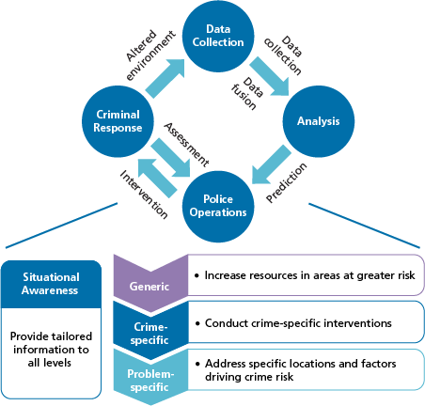

A four-step cycle, as depicted in the picture, is at the core of the system. The first two processes entail gathering and evaluating data on crimes, occurrences, and offenders in order to provide forecasts. The final phase is to carry out police actions to intervene based on the projections. As noted at the bottom of the picture, such interventions can be generic (i.e., an increase in resources), crime-specific, or problem-specific. The fourth phase is to hope that these measures will curb criminal activity or lead police to solve cases. To guarantee that there are no immediately evident difficulties, law enforcement officials should analyze the immediate effects of the intervention. Agencies should also monitor long-term trends by evaluating acquired data, doing additional analysis, and altering operations as needed.

Above is example of Manchester city where prediction policing is used, which resulted in a 12% decrease in robberies, a 21% decrease in burglaries, and a 32% decrease in vehicle theft. Machine learning and predictive analytics are being used by the Manchester Police Department on police data sets such as crime occurrences, arrests, and meteorological data. When historical data (such as prior arrest records) is paired with real-time IoT data, such as sensor-influenced cameras designed to detect gunshots, it becomes easier to spot problem places and comprehend the conditions that allow crime to thrive

**Why it is successful?**

Part of the reason for the lopsided success of common crimes like these is that they produce a large amount of historical data, which can readily be supplemented with additional information. Road network maps, for example, highlight which locations are easily accessible and can provide a speedy escape, and which are more restricted.

Weather data is also important in determining when robberies will occur. Robbers, it appears, dislike rain, therefore fair weather days are more likely occasions for crime.

**2.4 Social media crimes-:**

Of course, crimes committed in public are only one side of the coin. On the other hand, some are more difficult to predict — either because they appear to be random, isolated episodes, or because their offenders work under the cover of larger organizations that may hide them from view.

Some of these attacks, however, share similar traits that can assist identify them in advance. The social media boast is one of these. Would-be attackers or terrorists who can't stop bragging about themselves on Facebook leave useful traces for those who want to catch them: Detect the brag, apprehend the terrorist, and avert the assault**.**

**Challenges-:**

However, there are two drawbacks to this strategy. The first is the sheer amount of social media content available. Post numbers are in the billions, and sorting through them all is a difficult task.

The second issue is that many people say things on social media that they do not mean. When you're separated from face-to-face interaction by a protecting and sometimes anonymizing distance, it's simpler to post inflated, rage-fueled content than it is to say something similar in person. So, how can we distinguish between what is harmful and what is simply unpleasant? Can technology assist in making that distinction?

**2.5 White Collar Crime**

White collar crime is evolving and expanding. Identity theft, hacking, and other forms of white collar crime are transforming the face of white collar crime as it transitions from a businessman to a cyber criminal. This means that preparing and catching criminals will become increasingly vital as they attack individual data stored by organizations or "phish" an older populace.

Finding these crimes before they happen is also critical, because something like fraud (which accounts for a 5% revenue loss for most organizations each year) is not reported 40% of the time, with fear of negative publicity being the number one reason not to report. This means that tracking down white-collar criminals would be a wonderful use of big data, which could track high-risk attacks or evaluate systems in general. Because data breaches can frequently go undetected for months, it's critical to use big data to predict them before they happen. If we identify a high-risk region for cybercrime, we can set traps for would-be criminals and catch a crime that might otherwise go unreported.

**2.6 Big Data Helps to Reduce Racial Bias**

America's policing has a major problem with racism. Not only with actual legislation, but also with police officers. As members of the general population, police officers may reflect part of our society's racism. One manifestation of this is the way police captures drug offences. Whether it's because of regulations like those governing cocaine and crack, or because, despite the fact that black and white individuals use drugs at roughly the same rate, black people are four times more likely to be arrested for drug use and possession.

The importance of tracking actual crime information cannot be overstated! It will help police forces to police more effectively. It will enable legislators and policymakers to develop useful legislation based on facts with less bias.

**3. Crime-prevention analytics tools**

Large corporations such as IBM, SAS, and many others have contributed different analytical tools to this subject, which are actively utilized by law enforcement and are also extremely successful in flattening the curve.

**3.1 Predpol-:**

PredPol, the most well-known predictive policing program, was created and originally utilized by the Los Angeles and Santa Cruz police departments. With a 500-square-foot precision, the software can anticipate where crimes are likely to occur. Data-driven cops can already boast some impressive results: in Los Angeles, there was a 33% decrease in burglaries and a 21% decrease in violent crimes in areas where the software was used. It's no surprise that the groundbreaking new program has piqued the interest of city officials in neighboring places. The Atlanta Police Department implemented PredPol, which resulted in a 19 percent decrease in total crime, and examples of other beneficial deployments have proliferated. PredPol software is now being tested in over 150 cities across the United States, with more cities likely to follow.

The technique consists of software that collects data and analyzes previous criminal activity to predict where future crimes will occur. This analysis can take the shape of maps of crime hotspots or reports that indicate links between a perpetrator's previous criminal activities, crime sites, and any information that would aid in tracking that person down, such as previous known residences. These tools can take a procedure that used to need many database lookups and manual effort to print and map out links and speed it up such that data is delivered to police practically instantly with daily or even hourly updates.

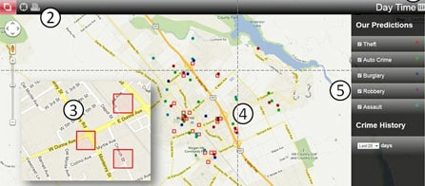

The algorithm that takes the data and forecasts it is the key to the analysis. Each tool has its own algorithm, which is a mathematical formula that connects data points. Some are unique, while others are based on NASA and weather forecasting systems. In regular civilian life, examples of such algorithms include Netflix's movie recommendations and Amazon's shopping recommendations. These algorithms forecast what will happen based on what has happened in predictive policing. The computer analysis may predict high-crime areas and periods, as well as individuals who are at danger of committing crimes. It can also provide strategies for identifying prior perpetrators by connecting them with past crimes, or it can forecast which groups or individuals are at high risk of becoming victims.

The software analyzes the data and generates reports for law enforcement authorities, who then decide what actions to take. This is where the method, rather than the technology, comes into play.

**3.2 Copylink Software By IBM-:**

Other large analytic tool developers, such as IBM, clearly do not lag behind. IBM is well-known for purchasing analytic start-ups and spending billions of dollars on predictive software. They released Copylink software a few years ago, which allows police agencies throughout the United States to mine each other's databases to find wanted people. Even if someone was arrested in Arizona for jaywalking, police officers would be able to compare his personal data and identify him on the spot as the suspected killer from North Dakota hundreds of miles away.A screenshot of a map

Above is one of the Copylink software applications in which police patrols are organized based on the crime rate and locations from the previous day. This simplifies their work and allows them to find trends based on past data.

Officers can use mobile devices and IBM i2 COPLINK Everywhere to:

• Use rapid search and full-form search to search interagency data.

• Capture photographs and apply face match technology at the site to determine if there is a criminal profile match.

• Create a map of particular threats or situations for near-real-time situational awareness.

• Keep an eye on people of interest in near real time.

• From the field, gain access to the highly secure i2 COPLINK database.

**3.RTM Dx**-:

A crime prevention app developed by Rutgers University researchers is one such tool that is already being utilized by police agencies in Colorado, Texas, Missouri, New Jersey, Arizona, and Illinois. RTM Dx is an app that uses geolocation and crime data to calculate the spatial correlation between where crimes have happened and various elements of the environment, such as nightclubs or bars. Officers can use this to measure correlations between different places and crime rates, and then decide which linkages are worth monitoring and pursuing.

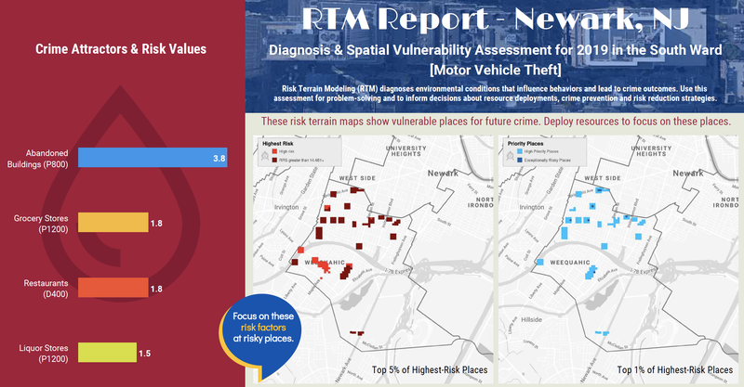

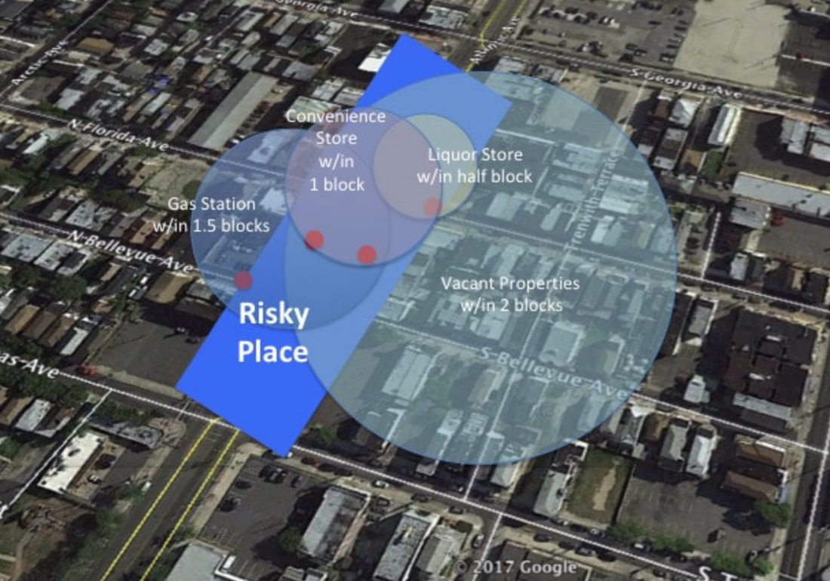

It provides police with a much-needed start in detecting crime and determining where police patrol is required every now and then.

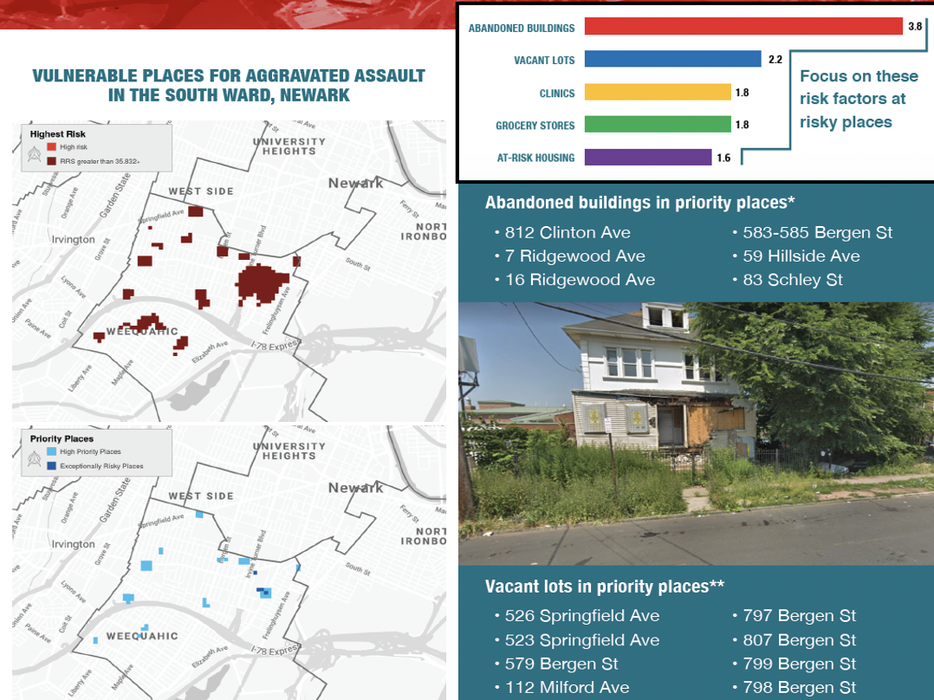

The Newark Public Safety Collaborative commissioned these reports. Knowing where to go and what to look for when you arrive makes crime prevention efforts more efficient and effective. You can also coordinate resources other than policing and law enforcement. You can collaborate with other city agencies and community groups to assist them prioritize where they are most needed.

**4.Conclusion-:**

We all know that big data has enormous promise and that it can do far more than we believe or expect. However, many law enforcement organizations continue to adopt old-school approaches because they do not want to leave their comfort zone. Here, the government and higher authorities should educate them with the usage of these tools and make them aware of how it would make their own lives easier while also boosting the overall process.

Today's law enforcement personnel have an incredible quantity of information that can assist them solve crimes, ranging from store security cameras to historical police complaints to evidence from onlookers' mobile phones.

Officers are now able to put together evidence that may otherwise look unrelated by using previously untapped or unused data types into the investigative process. Combining data such as crime and arrest records, field interview cards, automatic license plate readers, DMV information and rap sheets, as well as publicly available camera footage and police body cameras, is assisting in the implementation of effective policing programs across the country.

When all of this information is combined with data analytics tools and the necessary individuals to make sense of the data and respond swiftly, the result is a perfect equation that may make criminals quiver with fear.

**References-:**

[**https://www.ibm.com/blogs/internet-of-things/big-data-crime-prevention/**](https://www.ibm.com/blogs/internet-of-things/big-data-crime-prevention/)

[**https://www.wired.com/insights/2014/03/big-data-law-enforcement-minority-report-right/**](https://www.wired.com/insights/2014/03/big-data-law-enforcement-minority-report-right/)

[**https://bestarion.com/how-big-data-helps-to-fight-crime/**](https://bestarion.com/how-big-data-helps-to-fight-crime/)

[**https://bigdataanalyticsnews.com/how-big-data-is-changing-law-enforcement/**](https://bigdataanalyticsnews.com/how-big-data-is-changing-law-enforcement/)

[**https://www.prnewswire.com/news-releases/predictive-policing-big-potential-as-big-data-fights-crime-301247867.html**](https://www.prnewswire.com/news-releases/predictive-policing-big-potential-as-big-data-fights-crime-301247867.html)

[**https://www.ojp.gov/ncjrs/virtual-library/abstracts/criminal-profiling-viable-investigative-tool-against-violent-crime**](https://www.ojp.gov/ncjrs/virtual-library/abstracts/criminal-profiling-viable-investigative-tool-against-violent-crime)

[**https://www.ibm.com/analytics/nz/en/industry/government/mobile-crime-investigation.shtml?mhsrc=ibmsearch_a&mhq=copylink**](https://www.ibm.com/analytics/nz/en/industry/government/mobile-crime-investigation.shtml?mhsrc=ibmsearch_a&mhq=copylink)

[**https://techcrunch.com/2016/07/25/how-predictive-analytics-discovers-a-data-breach-before-it-happens/**](https://techcrunch.com/2016/07/25/how-predictive-analytics-discovers-a-data-breach-before-it-happens/)

[**https://www.ibm.com/blogs/internet-of-things/big-data-crime-prevention/**](https://www.ibm.com/blogs/internet-of-things/big-data-crime-prevention/)

[**https://www.splunk.com/en_us/blog/platform/predicting-and-preventing-crime-with-machine-learning-part-1.html**](https://www.splunk.com/en_us/blog/platform/predicting-and-preventing-crime-with-machine-learning-part-1.html)

[**https://www.rutgerscps.org/rtm-intro.html**](https://www.rutgerscps.org/rtm-intro.html)